**ASSIGNMENT 5**

**AIM:-**

PL/SQL Stored Procedure and Stored Function : Write a PL/SQL procedure to find

the number of students ranging from 100-80%, 79-70%, 69-60%,59-50 & below 49%

in each course from the Student_course table given by the procedure as parameter.

Student_course (Roll_no, Course, Course_code, Semester,Total_Marks, Percentage).

**OBJECTIVE:-**

To implement PL/SQL Stored Procedure.

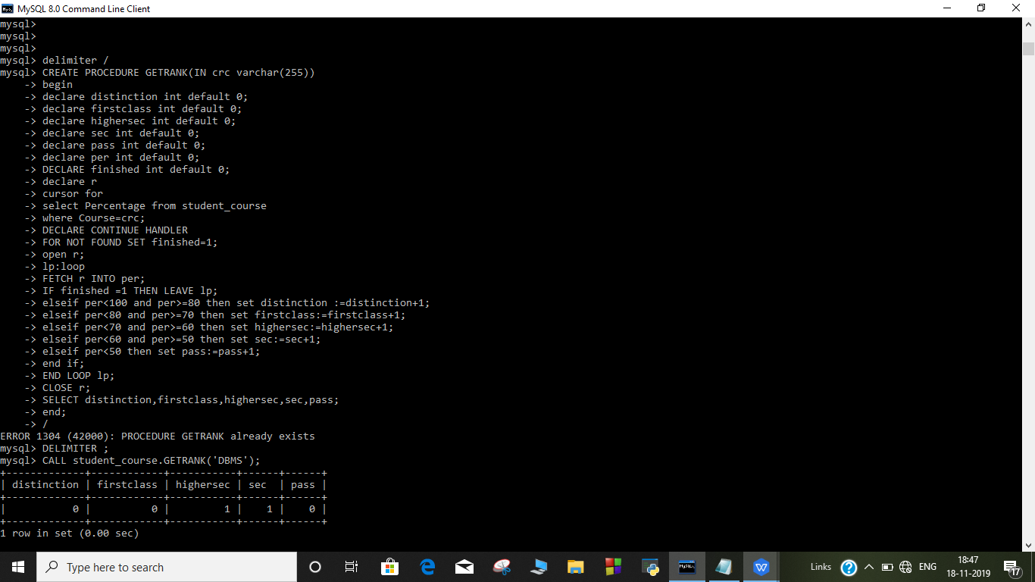

**OUTPUT:-**



